# EthernetContainer

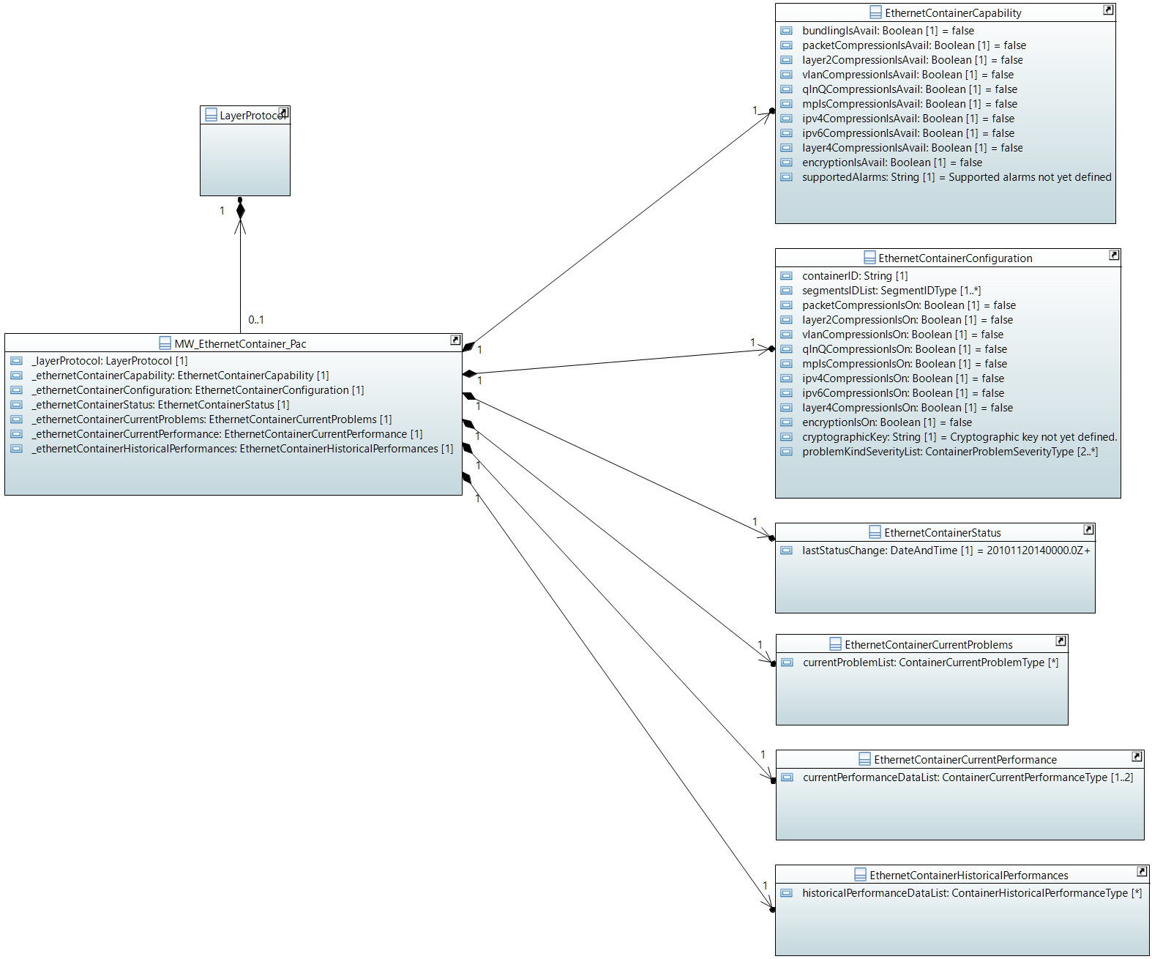

## MW_EthernetContainer_Pac

Qualified Name: MicrowaveModel::ObjectClasses::EthernetContainer::MW_EthernetContainer_Pac

Applied stereotypes:

* OpenModelClass
* objectCreationNotification: YES
* objectDeletionNotification: YES
* support: MANDATORY

Table 24: Attributes for MW_EthernetContainer_Pac

| **Attribute Name** | **Type DefaultValue** | **Multiplicity** | **Access** | **Stereotypes** | **Description** |
| --- | --- | --- | --- | --- | --- |
| _layerProtocol | LayerProtocol  ./. | 1 | RW | OpenModelAttribute   * partOfObjectKey: 1 * AVC: NO * isInvariant: false * valueRange: no range constraint * bitLength: NA * unit: no unit defined * support: MANDATORY | CoreModel-CoreNetworkModule-ObjectClasses:NetworkElement/_ltpRefList/_lpList/uuid |
| _ethernetContainerCapability | EthernetContainerCapability  ./. | 1 | R | OpenModelAttribute   * partOfObjectKey: 0 * AVC: NO * isInvariant: false * valueRange: no range constraint * bitLength: NA * unit: no unit defined * support: MANDATORY | See referenced class |
| _ethernetContainerConfiguration | EthernetContainerConfiguration  ./. | 1 | RW | OpenModelAttribute   * partOfObjectKey: 0 * AVC: NO * isInvariant: false * valueRange: no range constraint * bitLength: NA * unit: no unit defined * support: MANDATORY | See referenced class |
| _ethernetContainerStatus | EthernetContainerStatus  ./. | 1 | R | OpenModelAttribute   * partOfObjectKey: 0 * AVC: NO * isInvariant: false * valueRange: no range constraint * bitLength: NA * unit: no unit defined * support: MANDATORY | See referenced class |
| _ethernetContainerCurrentProblems | EthernetContainerCurrentProblems  ./. | 1 | R | OpenModelAttribute   * partOfObjectKey: 0 * AVC: NO * isInvariant: false * valueRange: no range constraint * bitLength: NA * unit: no unit defined * support: MANDATORY | See referenced class |
| _ethernetContainerCurrentPerformance | EthernetContainerCurrentPerformance  ./. | 1 | R | OpenModelAttribute   * partOfObjectKey: 0 * AVC: NO * isInvariant: false * valueRange: no range constraint * bitLength: NA * unit: no unit defined * support: MANDATORY | See referenced class |
| _ethernetContainerHistoricalPerformances | EthernetContainerHistoricalPerformances  ./. | 1 | R | OpenModelAttribute   * partOfObjectKey: 0 * AVC: NO * isInvariant: false * valueRange: no range constraint * bitLength: NA * unit: no unit defined * support: MANDATORY | See referenced class |

## EthernetContainerCapability

Qualified Name: MicrowaveModel::ObjectClasses::EthernetContainer::EthernetContainerCapability

Applied stereotypes:

* OpenModelClass
* objectCreationNotification: NO
* objectDeletionNotification: NO
* support: MANDATORY

Table 25: Attributes for EthernetContainerCapability

| **Attribute Name** | **Type DefaultValue** | **Multiplicity** | **Access** | **Stereotypes** | **Description** |
| --- | --- | --- | --- | --- | --- |
| bundlingIsAvail | Boolean  false | 1 | R | OpenModelAttribute   * partOfObjectKey: 0 * AVC: NO * isInvariant: true * valueRange: no range constraint * bitLength: NA * unit: no unit defined * support: MANDATORY | This attribute has to be set on 'true', if the device allows combining resources from several air interfaces for transporting this Ethernet container. |
| packetCompressionIsAvail | Boolean  false | 1 | R | OpenModelAttribute   * partOfObjectKey: 0 * AVC: NO * isInvariant: true * valueRange: no range constraint * bitLength: NA * unit: no unit defined * support: MANDATORY | In case packet compression can be activated, but not configured to a certain type, packetCompressionAvail shall be set on 'true', but none of the compression level specific booleans. |
| layer2CompressionIsAvail | Boolean  false | 1 | R | OpenModelAttribute   * partOfObjectKey: 0 * AVC: NO * isInvariant: true * valueRange: no range constraint * bitLength: NA * unit: no unit defined * support: MANDATORY | Packet compression on layer 2 available at the device. |
| vlanCompressionIsAvail | Boolean  false | 1 | R | OpenModelAttribute   * partOfObjectKey: 0 * AVC: NO * isInvariant: true * valueRange: no range constraint * bitLength: NA * unit: no unit defined * support: MANDATORY | Packet compression on VLAN layer available at the device. |
| qInQCompressionIsAvail | Boolean  false | 1 | R | OpenModelAttribute   * partOfObjectKey: 0 * AVC: NO * isInvariant: true * valueRange: no range constraint * bitLength: NA * unit: no unit defined * support: MANDATORY | Packet compression on layer of a second VLAN available at the device. |
| mplsCompressionIsAvail | Boolean  false | 1 | R | OpenModelAttribute   * partOfObjectKey: 0 * AVC: NO * isInvariant: true * valueRange: no range constraint * bitLength: NA * unit: no unit defined * support: MANDATORY | Packet compression on mpls layer available at the device. |
| ipv4CompressionIsAvail | Boolean  false | 1 | R | OpenModelAttribute   * partOfObjectKey: 0 * AVC: NO * isInvariant: true * valueRange: no range constraint * bitLength: NA * unit: no unit defined * support: MANDATORY | Packet compression on layer 3 for IPv4 available at the device. |
| ipv6CompressionIsAvail | Boolean  false | 1 | R | OpenModelAttribute   * partOfObjectKey: 0 * AVC: NO * isInvariant: true * valueRange: no range constraint * bitLength: NA * unit: no unit defined * support: MANDATORY | Packet compression on layer 3 for IPv6 available at the device. |
| layer4CompressionIsAvail | Boolean  false | 1 | R | OpenModelAttribute   * partOfObjectKey: 0 * AVC: NO * isInvariant: true * valueRange: no range constraint * bitLength: NA * unit: no unit defined * support: MANDATORY | Packet compression on layer 4 (TCP and UDP header) available at the device. |
| encryptionIsAvail | Boolean  false | 1 | R | OpenModelAttribute   * partOfObjectKey: 0 * AVC: NO * isInvariant: true * valueRange: no range constraint * bitLength: NA * unit: no unit defined * support: MANDATORY | Shall be marked 'true', if Ethernet payload encryption is available. |
| supportedAlarms | String  Supported alarms not yet defined. | 1 | R | OpenModelAttribute   * partOfObjectKey: 0 * AVC: NO * isInvariant: true * valueRange: no range constraint * bitLength: NA * unit: no unit defined * support: MANDATORY | Available alarms to be listed. Mandatory:'framingIsFaulty' and 'containerIsDown'. Further alarms might be added by the device. |

## EthernetContainerConfiguration

Qualified Name: MicrowaveModel::ObjectClasses::EthernetContainer::EthernetContainerConfiguration

Applied stereotypes:

* OpenModelClass
* objectCreationNotification: NO
* objectDeletionNotification: NO
* support: MANDATORY

Table 26: Attributes for EthernetContainerConfiguration

| **Attribute Name** | **Type DefaultValue** | **Multiplicity** | **Access** | **Stereotypes** | **Description** |
| --- | --- | --- | --- | --- | --- |
| containerID | String  No Ethernet Flow associated yet. | 1 | RW | OpenModelAttribute   * partOfObjectKey: 0 * AVC: YES * isInvariant: false * valueRange: no range constraint * bitLength: NA * unit: no unit defined * support: MANDATORY | ContainterID in Netconf must be the same as EthernetPortID in OpenFlow so a connection can be made between the two items, which separately exist in the controller. |
| segmentsIDList | SegmentIDType  ./. | 1..* | RW | OpenModelAttribute   * partOfObjectKey: 0 * AVC: YES * isInvariant: false * valueRange: no range constraint * bitLength: NA * unit: no unit defined * support: MANDATORY | Lists the segments used for transporting this Ethernet container. In case EthernetContainer::ContainerCapability::bundlingIsAvail==0, all TypeDefinitions::segmentIdType::structureId must be identical in the list. |
| packetCompressionIsOn | Boolean  false | 1 | RW | OpenModelAttribute   * partOfObjectKey: 0 * AVC: YES * isInvariant: false * valueRange: no range constraint * bitLength: NA * unit: no unit defined * support: MANDATORY | In case packet compression is activated, but no type is activated, it is assumed that the device chooses the optimum. |
| layer2CompressionIsOn | Boolean  false | 1 | RW | OpenModelAttribute   * partOfObjectKey: 0 * AVC: YES * isInvariant: false * valueRange: no range constraint * bitLength: NA * unit: no unit defined * support: MANDATORY | Packet compression on layer 2 configured at the device. |
| vlanCompressionIsOn | Boolean  false | 1 | RW | OpenModelAttribute   * partOfObjectKey: 0 * AVC: YES * isInvariant: false * valueRange: no range constraint * bitLength: NA * unit: no unit defined * support: MANDATORY | Packet compression on VLAN layer configured at the device. |
| qInQCompressionIsOn | Boolean  false | 1 | RW | OpenModelAttribute   * partOfObjectKey: 0 * AVC: YES * isInvariant: false * valueRange: no range constraint * bitLength: NA * unit: no unit defined * support: MANDATORY | Packet compression on layer of a second VLAN configured at the device. |
| mplsCompressionIsOn | Boolean  false | 1 | RW | OpenModelAttribute   * partOfObjectKey: 0 * AVC: YES * isInvariant: false * valueRange: no range constraint * bitLength: NA * unit: no unit defined * support: MANDATORY | Packet compression on MPLS layer configured at the device. |
| ipv4CompressionIsOn | Boolean  false | 1 | RW | OpenModelAttribute   * partOfObjectKey: 0 * AVC: YES * isInvariant: false * valueRange: no range constraint * bitLength: NA * unit: no unit defined * support: MANDATORY | Packet compression on layer 3 for IPv4 configured at the device. |
| ipv6CompressionIsOn | Boolean  false | 1 | RW | OpenModelAttribute   * partOfObjectKey: 0 * AVC: YES * isInvariant: false * valueRange: no range constraint * bitLength: NA * unit: no unit defined * support: MANDATORY | Packet compression on layer 3 for IPv6 configured at the device. |
| layer4CompressionIsOn | Boolean  false | 1 | RW | OpenModelAttribute   * partOfObjectKey: 0 * AVC: YES * isInvariant: false * valueRange: no range constraint * bitLength: NA * unit: no unit defined * support: MANDATORY | Packet compression on layer 4 (TCP and UDP header) configured at the device. |
| encryptionIsOn | Boolean  false | 1 | RW | OpenModelAttribute   * partOfObjectKey: 0 * AVC: YES * isInvariant: false * valueRange: no range constraint * bitLength: NA * unit: no unit defined * support: MANDATORY | Activates encryption of the Ethernet payload. |
| cryptographicKey | String  Cryptographic key not yet defined. | 1 | RW | OpenModelAttribute   * partOfObjectKey: 0 * AVC: YES * isInvariant: false * valueRange: no range constraint * bitLength: NA * unit: no unit defined * support: MANDATORY | Key for transforming plaintext into cipher text data. |
| problemKindSeverityList | ContainerProblemSeverityType  ./. | 2..* | RW | OpenModelAttribute   * partOfObjectKey: 0 * AVC: YES * isInvariant: false * valueRange: no range constraint * bitLength: NA * unit: no unit defined * support: MANDATORY | Severity of the problem to be configured. |

## EthernetContainerStatus

Qualified Name: MicrowaveModel::ObjectClasses::EthernetContainer::EthernetContainerStatus

Applied stereotypes:

* OpenModelClass
* objectCreationNotification: NO
* objectDeletionNotification: NO
* support: MANDATORY

Table 27: Attributes for EthernetContainerStatus

| **Attribute Name** | **Type DefaultValue** | **Multiplicity** | **Access** | **Stereotypes** | **Description** |
| --- | --- | --- | --- | --- | --- |
| lastStatusChange | DateAndTime  20101120140000.0Z+1 | 1 | R | OpenModelAttribute   * partOfObjectKey: 0 * AVC: NO * isInvariant: false * valueRange: no range constraint * bitLength: NA * unit: no unit defined * support: MANDATORY | Time the Container entered its current operational status. _format:yyyyMMddhhmmss.s[Z|{+|-}HHMm]; yyyy='0000'..'9999' year; MM='01'..'12' month; dd='01'..'31' day; hh='00'..'23' hour; mm='00'..'59' minute; ss='00'..'59' second; s='.0'..'.9'tenth of second (set to '.0' if EMS or NE cannot support this granularity); Z='Z' indicates UTC (rather than local time); {+|-}='+' or '-' delta from UTC; HH='00'..'23' time zone difference in hours; Mm='00'..'59' time zone difference in minutes. |

## EthernetContainerCurrentProblems

Qualified Name: MicrowaveModel::ObjectClasses::EthernetContainer::EthernetContainerCurrentProblems

Applied stereotypes:

* OpenModelClass
* objectCreationNotification: NO
* objectDeletionNotification: NO
* support: MANDATORY

Table 28: Attributes for EthernetContainerCurrentProblems

| **Attribute Name** | **Type DefaultValue** | **Multiplicity** | **Access** | **Stereotypes** | **Description** |
| --- | --- | --- | --- | --- | --- |
| currentProblemList | ContainerCurrentProblemType  ./. | 0..* | R | OpenModelAttribute   * partOfObjectKey: 0 * AVC: NO * isInvariant: false * valueRange: no range constraint * bitLength: NA * unit: no unit defined * support: MANDATORY |  |

## EthernetContainerCurrentPerformance

Qualified Name: MicrowaveModel::ObjectClasses::EthernetContainer::EthernetContainerCurrentPerformance

Aggregated performance information of the Ethernet container at a particular moment.

Applied stereotypes:

* OpenModelClass
* objectCreationNotification: NO
* objectDeletionNotification: NO
* support: MANDATORY

Table 29: Attributes for EthernetContainerCurrentPerformance

| **Attribute Name** | **Type DefaultValue** | **Multiplicity** | **Access** | **Stereotypes** | **Description** |
| --- | --- | --- | --- | --- | --- |
| currentPerformanceDataList | ContainerCurrentPerformanceType  ./. | 1..2 | R | OpenModelAttribute   * partOfObjectKey: 0 * AVC: NO * isInvariant: false * valueRange: no range constraint * bitLength: NA * unit: no unit defined * support: MANDATORY |  |

## EthernetContainerHistoricalPerformances

Qualified Name: MicrowaveModel::ObjectClasses::EthernetContainer::EthernetContainerHistoricalPerformances

Aggregated performance information of the Ethernet container for a pre-defined measurement interval.

Applied stereotypes:

* OpenModelClass
* objectCreationNotification: NO
* objectDeletionNotification: NO
* support: MANDATORY

Table 30: Attributes for EthernetContainerHistoricalPerformances

| **Attribute Name** | **Type DefaultValue** | **Multiplicity** | **Access** | **Stereotypes** | **Description** |
| --- | --- | --- | --- | --- | --- |
| historicalPerformanceDataList | ContainerHistoricalPerformanceType  ./. | 0..* | R | OpenModelAttribute   * partOfObjectKey: 0 * AVC: NO * isInvariant: false * valueRange: no range constraint * bitLength: NA * unit: no unit defined * support: MANDATORY |  |

# Data Types

## ContainerProblemSeverityType

Qualified Name: MicrowaveModel::TypeDefinitions::ContainerProblemSeverityType

Table 69: Attributes for ContainerProblemSeverityType

| **Attribute Name** | **Type DefaultValue** | **Multiplicity** | **Access** | **Stereotypes** | **Description** |
| --- | --- | --- | --- | --- | --- |
| problemKindName | String  Problem kind name not defined. | 1 | RW | OpenModelAttribute   * partOfObjectKey: 1 * AVC: NA * isInvariant: true * valueRange: no range constraint * bitLength: NA * unit: no unit defined * support: MANDATORY | Name of the alarm according to Container::ContainerCapability::supportedAlarms |
| problemKindSeverity | SeverityType  WARNING | 1 | RW | OpenModelAttribute   * partOfObjectKey: 0 * AVC: YES * isInvariant: false * valueRange: no range constraint * bitLength: NA * unit: no unit defined * support: MANDATORY | Severity of this type of alarm. |

## ContainerCurrentProblemType

Qualified Name: MicrowaveModel::TypeDefinitions::ContainerCurrentProblemType

Table 70: Attributes for ContainerCurrentProblemType

| **Attribute Name** | **Type DefaultValue** | **Multiplicity** | **Access** | **Stereotypes** | **Description** |
| --- | --- | --- | --- | --- | --- |
| problemName | String  Problem name not specified. | 1 | R | OpenModelAttribute   * partOfObjectKey: 0 * AVC: NO * isInvariant: true * valueRange: no range constraint * bitLength: NA * unit: no unit defined * support: MANDATORY | Name of the alarm according to Container::ContainerCapability::supportedAlarms |

## ContainerPerformanceType

Qualified Name: MicrowaveModel::TypeDefinitions::ContainerPerformanceType

Consolidated performance information of the Container.

Table 71: Attributes for ContainerPerformanceType

| **Attribute Name** | **Type DefaultValue** | **Multiplicity** | **Access** | **Stereotypes** | **Description** |
| --- | --- | --- | --- | --- | --- |
| txEthernetBytesMaxS | Integer  -1 | 1 | R | OpenModelAttribute   * partOfObjectKey: 0 * AVC: NO * isInvariant: true * valueRange: no range constraint * bitLength: LENGTH_32_BIT * unit: Bytes/s * support: MANDATORY | Counts the number of Bytes of Ethernet traffic (before header compression) transmitted within a second and keeps the highest value within the measurement period. Field to be left blank for all types of TDM containers. |
| txEthernetBytesMaxM | Integer  -1 | 1 | R | OpenModelAttribute   * partOfObjectKey: 0 * AVC: NO * isInvariant: true * valueRange: no range constraint * bitLength: LENGTH_64_BIT * unit: Bytes/min * support: MANDATORY | Counts the number of Bytes of Ethernet traffic (before header compression) transmitted within a minute and keeps the highest value with in the measurement period. Field to be left blank for all types of TDM containers. |
| txEthernetBytesSum | Integer  -1 | 1 | R | OpenModelAttribute   * partOfObjectKey: 0 * AVC: NO * isInvariant: true * valueRange: no range constraint * bitLength: LENGTH_64_BIT * unit: Bytes * support: MANDATORY | Total number of Bytes of Ethernet traffic (before header compression) transmitted (in direction out of the device) during the measurement period. Field to be left blank for all types of TDM containers. |
| timePeriod | Integer  -1 | 1 | R | OpenModelAttribute   * partOfObjectKey: 0 * AVC: NO * isInvariant: true * valueRange: no range constraint * bitLength: LENGTH_32_BIT * unit: s * support: MANDATORY | Total length of the measurement period in seconds. |

## ContainerCurrentPerformanceType

Qualified Name: MicrowaveModel::TypeDefinitions::ContainerCurrentPerformanceType

Turns performance information into current performance information by inheriting from OTN_CurrentData.

Table 72: Attributes for ContainerCurrentPerformanceType

| **Attribute Name** | **Type DefaultValue** | **Multiplicity** | **Access** | **Stereotypes** | **Description** |
| --- | --- | --- | --- | --- | --- |
| performanceData | ContainerPerformanceType  ./. | 1 | R | OpenModelAttribute   * partOfObjectKey: 0 * AVC: NO * isInvariant: true * valueRange: no range constraint * bitLength: NA * unit: no unit defined * support: MANDATORY |  |

## ContainerHistoricalPerformanceType

Qualified Name: MicrowaveModel::TypeDefinitions::ContainerHistoricalPerformanceType

Turns performance information into historical performance information by inheriting from OTN_HistoryData.

Table 73: Attributes for ContainerHistoricalPerformanceType

| **Attribute Name** | **Type DefaultValue** | **Multiplicity** | **Access** | **Stereotypes** | **Description** |
| --- | --- | --- | --- | --- | --- |
| performanceData | ContainerPerformanceType  ./. | 1 | R | OpenModelAttribute   * partOfObjectKey: 0 * AVC: NO * isInvariant: true * valueRange: no range constraint * bitLength: NA * unit: no unit defined * support: MANDATORY |  |

# Super Classes

## MwCurrentProblem

Qualified Name: MicrowaveModel::ObjectClasses::SuperClasses::MwCurrentProblem

Applied stereotypes:

* OpenModelClass
* objectCreationNotification: NO
* objectDeletionNotification: NO
* support: MANDATORY

Table 74: Attributes for MwCurrentProblem

| **Attribute Name** | **Type DefaultValue** | **Multiplicity** | **Access** | **Stereotypes** | **Description** |
| --- | --- | --- | --- | --- | --- |
| sequenceNumber | Integer  ./. | 1 | R | OpenModelAttribute   * partOfObjectKey: 1 * AVC: NO * isInvariant: true * valueRange: no range constraint * bitLength: LENGTH_32_BIT * unit: no unit defined * support: MANDATORY | Unique sequence number of the current problem object. |
| timeStamp | DateAndTime  20101120140000.0Z+1 | 1 | R | OpenModelAttribute   * partOfObjectKey: 0 * AVC: NO * isInvariant: true * valueRange: no range constraint * bitLength: NA * unit: no unit defined * support: MANDATORY | Time and date of the problem. _format:yyyyMMddhhmmss.s[Z|{+|-}HHMm]; yyyy='0000'..'9999' year; MM='01'..'12' month; dd='01'..'31' day; hh='00'..'23' hour; mm='00'..'59' minute; ss='00'..'59' second; s='.0'..'.9'tenth of second (set to '.0' if EMS or NE cannot support this granularity); Z='Z' indicates UTC (rather than local time); {+|-}='+' or '-' delta from UTC; HH='00'..'23' time zone difference in hours; Mm='00'..'59' time zone difference in minutes. |
| problemSeverity | SeverityType  WARNING | 1 | R | OpenModelAttribute   * partOfObjectKey: 0 * AVC: NO * isInvariant: true * valueRange: no range constraint * bitLength: NA * unit: no unit defined * support: MANDATORY | Severity of the alarm. |

# Notifications

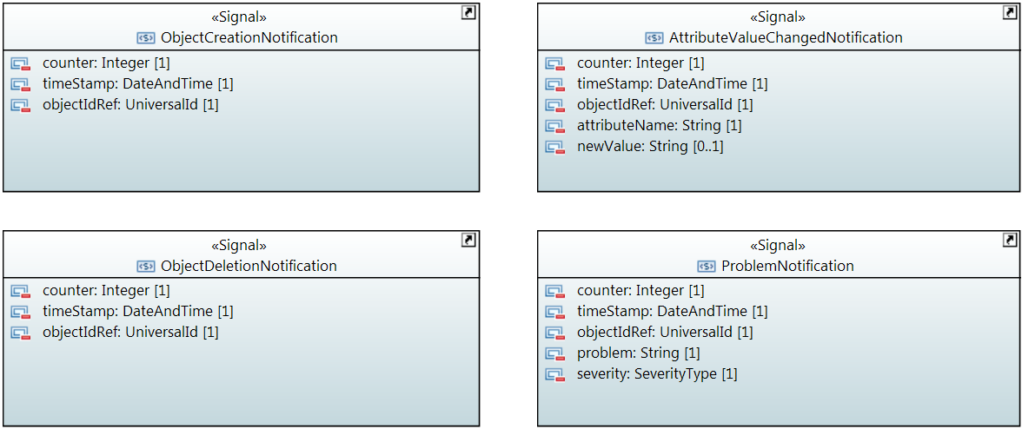

## AttributeValueChangedNotification

Qualified Name: MicrowaveModel::Notifications::AttributeValueChangedNotification

To be sent when an attribute has changed and one or more controllers have to update their data.

Applied stereotypes:

* OpenModelNotification
* triggerConditionList: invalid
* support: MANDATORY

Table 75: Attributes for AttributeValueChangedNotification

| **Attribute Name** | **Type DefaultValue** | **Multiplicity** | **Access** | **Stereotypes** | **Description** |
| --- | --- | --- | --- | --- | --- |
| counter | Integer  -1 | 1 | RW | OpenModelAttribute   * partOfObjectKey: 0 * AVC: NO * isInvariant: true * valueRange: no range constraint * bitLength: LENGTH_32_BIT * unit: no unit defined * support: MANDATORY | Counts attribute value changed notifications. |
| timeStamp | DateAndTime  20101120140000.0Z+1 | 1 | RW | OpenModelAttribute   * partOfObjectKey: 0 * AVC: NO * isInvariant: true * valueRange: no range constraint * bitLength: NA * unit: no unit defined * support: MANDATORY |  |
| objectIdRef | UniversalId  ./. | 1 | RW | OpenModelAttribute   * partOfObjectKey: 0 * AVC: NO * isInvariant: true * valueRange: no range constraint * bitLength: NA * unit: no unit defined * support: MANDATORY | ID of the affected MW_AirInterface_Pac, MW_AirInterfaceDiversity_Pac, MW_Structure_Pac, MW_PureEthernetStructure_Pac, MW_HybridMwStructure_Pac, MW_Container_Pac, MW_EthernetContainer_Pac or MW_TdmContainer_Pac. |
| attributeName | String  Attribute name not specified. | 1 | RW | OpenModelAttribute   * partOfObjectKey: 0 * AVC: NO * isInvariant: true * valueRange: no range constraint * bitLength: NA * unit: no unit defined * support: MANDATORY | Name of the attribute that has been changed. |
| newValue | String  New value not specified. | 0..1 | RW | OpenModelAttribute   * partOfObjectKey: 0 * AVC: NO * isInvariant: true * valueRange: no range constraint * bitLength: NA * unit: no unit defined * support: MANDATORY | Attribute value converted to a string (xml, json, ...) |

## ObjectCreationNotification

Qualified Name: MicrowaveModel::Notifications::ObjectCreationNotification

To be sent when a new MW_AirInterface_Pac, MW_AirInterfaceDiversity_Pac, MW_Structure_Pac, MW_PureEthernetStructure_Pac, MW_HybridMwStructure_Pac, MW_Container_Pac, MW_EthernetContainer_Pac or MW_TdmContainer_Pac has to be instancieted in the controller.

Applied stereotypes:

* OpenModelNotification
* triggerConditionList: invalid
* support: MANDATORY

Table 76: Attributes for ObjectCreationNotification

| **Attribute Name** | **Type DefaultValue** | **Multiplicity** | **Access** | **Stereotypes** | **Description** |
| --- | --- | --- | --- | --- | --- |
| counter | Integer  -1 | 1 | RW | OpenModelAttribute   * partOfObjectKey: 0 * AVC: NO * isInvariant: true * valueRange: no range constraint * bitLength: LENGTH_32_BIT * unit: no unit defined * support: MANDATORY | Counts object creation notifications. |
| timeStamp | DateAndTime  20101120140000.0Z+1 | 1 | RW | OpenModelAttribute   * partOfObjectKey: 0 * AVC: NO * isInvariant: true * valueRange: no range constraint * bitLength: NA * unit: no unit defined * support: MANDATORY |  |
| objectIdRef | UniversalId  ./. | 1 | RW | OpenModelAttribute   * partOfObjectKey: 0 * AVC: NO * isInvariant: true * valueRange: no range constraint * bitLength: NA * unit: no unit defined * support: MANDATORY | ID of the affected MW_AirInterface_Pac, MW_AirInterfaceDiversity_Pac, MW_Structure_Pac, MW_PureEthernetStructure_Pac, MW_HybridMwStructure_Pac, MW_Container_Pac, MW_EthernetContainer_Pac or MW_TdmContainer_Pac. |
| objectType | String  Type of created object not specified. | 1 | RW | OpenModelAttribute   * partOfObjectKey: 0 * AVC: NO * isInvariant: true * valueRange: no range constraint * bitLength: NA * unit: no unit defined * support: MANDATORY | Type of Object to be chosen from the following list of values: 'MW_AirInterface_Pac', 'MW_AirInterfaceDiversity_Pac', 'MW_Structure_Pac', 'MW_PureEthernetStructure_Pac', 'MW_HybridMwStructure_Pac', 'MW_Container_Pac', 'MW_EthernetContainer_Pac' or 'MW_TdmContainer_Pac'. |

## ObjectDeletionNotification

Qualified Name: MicrowaveModel::Notifications::ObjectDeletionNotification

To be sent when a new MW_AirInterface_Pac, MW_AirInterfaceDiversity_Pac, MW_Structure_Pac, MW_PureEthernetStructure_Pac, MW_HybridMwStructure_Pac, MW_Container_Pac, MW_EthernetContainer_Pac or MW_TdmContainer_Pac instance has to be deleted in the controller.

Applied stereotypes:

* OpenModelNotification
* triggerConditionList: invalid
* support: MANDATORY

Table 77: Attributes for ObjectDeletionNotification

| **Attribute Name** | **Type DefaultValue** | **Multiplicity** | **Access** | **Stereotypes** | **Description** |
| --- | --- | --- | --- | --- | --- |
| counter | Integer  -1 | 1 | RW | OpenModelAttribute   * partOfObjectKey: 0 * AVC: NO * isInvariant: true * valueRange: no range constraint * bitLength: LENGTH_32_BIT * unit: no unit defined * support: MANDATORY | Counts object deletion notifications. |
| timeStamp | DateAndTime  20101120140000.0Z+1 | 1 | RW | OpenModelAttribute   * partOfObjectKey: 0 * AVC: NO * isInvariant: true * valueRange: no range constraint * bitLength: NA * unit: no unit defined * support: MANDATORY |  |
| objectIdRef | UniversalId  ./. | 1 | RW | OpenModelAttribute   * partOfObjectKey: 0 * AVC: NO * isInvariant: true * valueRange: no range constraint * bitLength: NA * unit: no unit defined * support: MANDATORY | ID of the affected MW_AirInterface_Pac, MW_AirInterfaceDiversity_Pac, MW_Structure_Pac, MW_PureEthernetStructure_Pac, MW_HybridMwStructure_Pac, MW_Container_Pac, MW_EthernetContainer_Pac or MW_TdmContainer_Pac. |

## ProblemNotification

Qualified Name: MicrowaveModel::Notifications::ProblemNotification

To be sent when a problem occurs at a MW_AirInterface_Pac, MW_AirInterfaceDiversity_Pac, MW_Structure_Pac, MW_PureEthernetStructure_Pac, MW_HybridMwStructure_Pac, MW_Container_Pac, MW_EthernetContainer_Pac or MW_TdmContainer_Pac.

Applied stereotypes:

* OpenModelNotification
* triggerConditionList: invalid
* support: MANDATORY

Table 78: Attributes for ProblemNotification

| **Attribute Name** | **Type DefaultValue** | **Multiplicity** | **Access** | **Stereotypes** | **Description** |
| --- | --- | --- | --- | --- | --- |
| counter | Integer  -1 | 1 | RW | OpenModelAttribute   * partOfObjectKey: 0 * AVC: NO * isInvariant: true * valueRange: no range constraint * bitLength: LENGTH_32_BIT * unit: no unit defined * support: MANDATORY | Counts problem notifications |
| timeStamp | DateAndTime  20101120140000.0Z+1 | 1 | RW | OpenModelAttribute   * partOfObjectKey: 0 * AVC: NO * isInvariant: true * valueRange: no range constraint * bitLength: NA * unit: no unit defined * support: MANDATORY |  |
| objectIdRef | UniversalId  ./. | 1 | RW | OpenModelAttribute   * partOfObjectKey: 0 * AVC: NO * isInvariant: true * valueRange: no range constraint * bitLength: NA * unit: no unit defined * support: MANDATORY | ID of the affected MW_AirInterface_Pac, MW_AirInterfaceDiversity_Pac, MW_Structure_Pac, MW_PureEthernetStructure_Pac, MW_HybridMwStructure_Pac, MW_Container_Pac, MW_EthernetContainer_Pac or MW_TdmContainer_Pac. |
| problem | String  Problem name not specified. | 1 | RW | OpenModelAttribute   * partOfObjectKey: 0 * AVC: NO * isInvariant: true * valueRange: no range constraint * bitLength: NA * unit: no unit defined * support: MANDATORY | Name of the problem according to AirInterface::AirInterfaceCapability::supportedAlarms or AirInterfaceDiversity::AirInterfaceDiversityCapability::supportedAlarms or Structure::StructureCapability::supportedAlarms or PureEthernetStructure::PureEthernetStructureCapability::supportedAlarms or HybridMwStructure::HybridMwStructureCapability::supportedAlarms or Container::ContainerCapability::supportedAlarms or EthernetContainer::EthernetContainerCapability::supportedAlarms or TdmContainer::TdmContainerCapability::supportedAlarms. |
| severity | SeverityType  WARNING | 1 | RW | OpenModelAttribute   * partOfObjectKey: 0 * AVC: NO * isInvariant: true * valueRange: no range constraint * bitLength: NA * unit: no unit defined * support: MANDATORY | Severity of the problem according to AirInterface::AirInterfaceConfiguration::problemSeverityList, AirInterfaceDiversity::AirInterfaceDiversityConfiguration::problemSeverityList, Structure::StructureConfiguration::problemSeverityList, PureEthernetStructure::PureEthernetStructureConfiguration::problemSeverityList, HybridMwStructure::HybridMwStructureConfiguration::problemSeverityList, Container::ContainerConfiguration::problemSeverityList, EthernetContainer::EthernetContainerConfiguration::problemSeverityList or TdmContainer::TdmContainerConfiguration::problemSeverityList |